**INTRODUCTION TO PROGRAMMING (COIT20245)**

**Term 2, 2019**

**Assessment 1:**

|  |  |
| --- | --- |
| Student ID | 12116421 |
| Student Name | Bishal Budhathoki |
| Campus | Sydney (On-Campus) |
| Tutor | Aries Tao |

**Output:**

Here, N = 6

1. This output is obtained from the sample output given from the question.

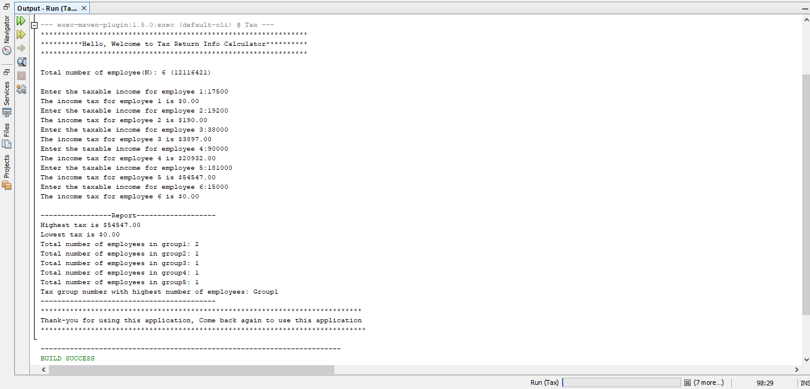

b) Here negative value is introduced for 6th employee and a message are displayed saying salary cannot be in negative. Also, here group 1 and group 5 have equal number of employees 2, so highest group number which is 5 is displayed.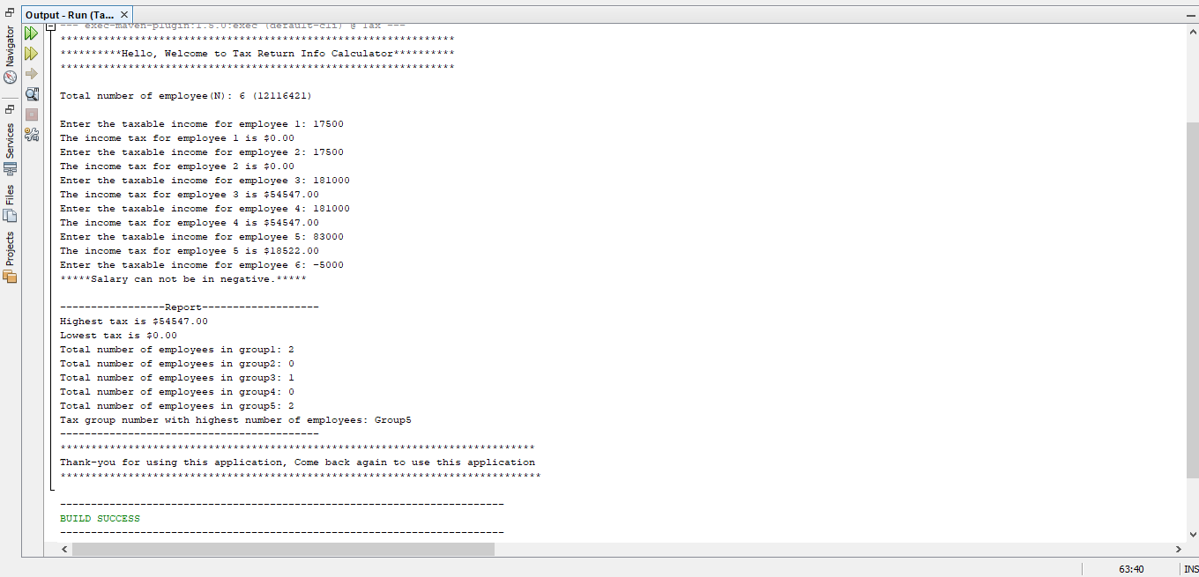

c) Here input is given alphabet not numeric value leading to an error.

